DEPARTMENT OF INFORMATION TECHNOLOGY

SMT. PARMESHWARIDEVI DURGADUTT TIBREWALA
LIONS JUHU COLLEGE
OF ARTS, COMMERCE AND SCIENCE
Affiliated to University of Mumbai (Autonomous)
J.B. NAGAR, ANDHERI (E), MUMBAI-400059


Academic Year 2025-2026

SOFT COMPUTING
For

Semester I

Submitted By:

Mr. Ahmed Dilshad Shaikh
Msc.IT (Sem I)

SMT. PARMESHWARIDEVI DURGADUTT TIBREWALA LIONS JUHU COLLEGE
OF ARTS, COMMERCE AND SCIENCE
Affiliated to University of Mumbai (Autonomous)
J.B. NAGAR, ANDHERI (E), MUMBAI-400059

DEPARTMENT OF INFORMATION TECHNOLOGY

Certificate of Approval

This is to certify that practical entitled “SOFT COMPUTING”, Undertaken at SMT.PARMESHWARIDEVI DURGADUTT TIBREWALA LIONS JUHU COLLEGE OF ARTS, COMMERCE & SCIENCE.
By Mr. Ahmed Dilshad Shaikh Seat No. MIT251009 in partial fulfilment of M.Sc. (IT) master degree (Semester I) Examination had not been submitted for any other examination and does not form of any other course undergone by the candidate. It is further certified that he has completed all required phases of the practical.

Internal Examiner External Examiner

HOD / In-Charge / Coordinator Signature/
Principal/Stamp

INDEX

Practical No | Details | Page No. | Date | Sign
1 | Implement the following | 4 | 11-10-2025
A | Design a simple linear neural network model
B | Calculate the output of neural network using both binary and  bipolar sigmoidal function
2 | Implement the following | 6 | 11-10-2025
A | Generate AND/NOT function using McCulloch-Pitts neural net.
B | Generate XOR function using McCulloch-Pitts neural net.
3 | Implement the Following | 10 | 11-10-2025
A | Write a program to implement Hebb’s rule.
B | Write a program to implement Delta rule.
4 | Implement the Following | 12 | 18-10-2025
A | Write a program for Back Propagation Algorithm.
B | Write a program for error Backpropagation algorithm.
5 | Write a program for Radial Basis function | 15 | 18-10-2025
6 | Kohonen Self organizing map | 17 | 18-10-2025
7 | Implement the Following | 18 | 15-11-2025
A | Write a program for Linear separation.
8 | Implement the Following | 20 | 15-11-2025
A | Membership and Identity Operators | in, not in.
B | Membership and Identity Operators is, is not
9 | Implement the Following | 22 | 15-11-2025
A | Find ratios using fuzzy logic
B | Solve Tipping problem using fuzzy logic

Practical 1a

Aim: Design a simple linear neural network model.
Code :
x=float(input("Enter value of x:")) w=float(input("Enter value of weight w:")) b=float(input("Enter value of bias b:")) net = int(w*x+b)
if(net<0):
out=0 elif((net>=0)&(net<=1)): out =net
else:
out=1 print("net=",net) print("output=",out)
Output :

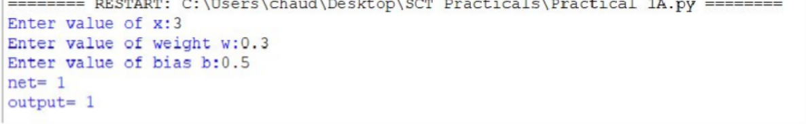

Practical 1b

Aim: Calculate the output of neural net using both binary and bipolar sigmoidal function.
Code :
# number of elements as input
n = int(input("Enter number of elements : ")) # In[2]:
print("Enter the inputs")
inputs = [] # creating an empty list for inputs # iterating till the range
for i in range(0, n):
ele = float(input())
inputs.append(ele) # adding the element print(inputs)
# In[3]:
print("Enter the weights")
# creating an empty list for weights weights = []
# iterating till the range for i in range(0, n):
ele = float(input())
weights.append(ele) # adding the element print(weights)
# In[4]:
print("The net input can be calculated as Yin = x1w1 + x2w2 + x3w3") # In[5]:
Yin = []
for i in range(0, n): Yin.append(inputs[i]*weights[i]) print(round(sum(Yin),3))
Output:
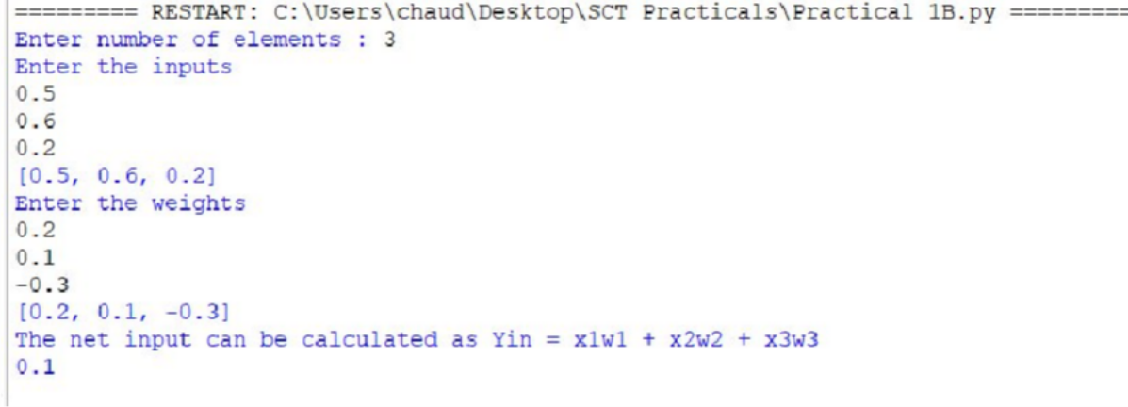

Practical 2a

Aim: Generate AND/NOT function using McCulloch-Pitts neural net.

Code :
# enter the no of inputs
num_ip = int(input("Enter the number of inputs : ")) #Set the weights with value 1
w1 = 1
w2 = 1
print("For the ", num_ip , " inputs calculate the net input using yin = x1w1 + x2w2 ") x1 = []
x2 = []
for j in range(0, num_ip):
ele1 = int(input("x1 = ")) ele2 = int(input("x2 = ")) x1.append(ele1) x2.append(ele2) print("x1 = ",x1)
print("x2 = ",x2) n = x1 * w1
m = x2 * w2 Yin = []
for i in range(0, num_ip):
Yin.append(n[i] + m[i]) print("Yin = ",Yin)
#Assume one weight as excitatory and the other as inhibitory, i.e., Yin = []
for i in range(0, num_ip):
Yin.append(n[i] - m[i])
print("After assuming one weight as excitatory and the other as inhibitory Yin = ",Yin) #From the calculated net inputs, now it is possible to fire the neuron for input (1, 0) #only by fixing a threshold of 1, i.e., θ ≥ 1 for Y unit.
#Thus, w1 = 1, w2 = -1; θ ≥ 1 Y=[]
for i in range(0, num_ip): if(Yin[i]>=1):
ele= 1 Y.append(ele) if(Yin[i]<1): ele= 0 Y.append(ele) print("Y = ",Y)

Output:

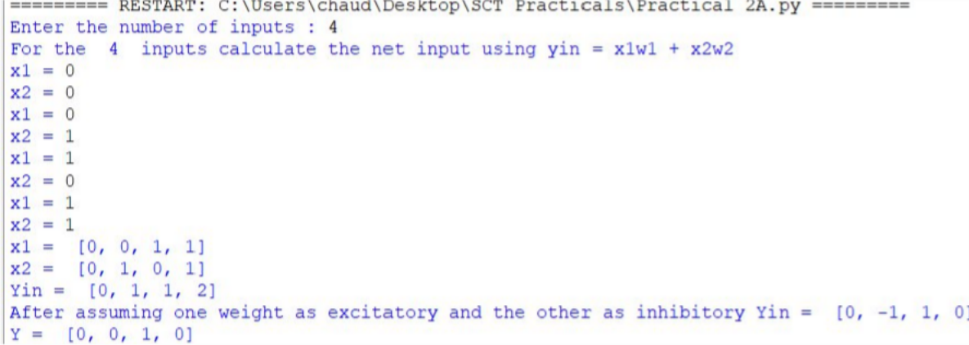

Practical 2b

Aim : Generate XOR function using McCulloch-Pitts neural net
Code:
import numpy as np print('Enter weights') w11=int(input('Weight w11=')) w12=int(input('weight w12=')) w21=int(input('Weight w21=')) w22=int(input('weight w22=')) v1=int(input('weight v1=')) v2=int(input('weight v2=')) print('Enter Threshold Value') theta=int(input('theta=')) x1=np.array([0, 0, 1, 1])
x2=np.array([0, 1, 0, 1])
z=np.array([0, 1, 1, 0]) con=1 y1=np.zeros((4,))
y2=np.zeros((4,))
y=np.zeros((4,)) while con==1: zin1=np.zeros((4,))
zin2=np.zeros((4,)) zin1=x1*w11+x2*w21 zin2=x1*w21+x2*w22 print("z1",zin1)
print("z2",zin2) for i in range(0,4): if zin1[i]>=theta: y1[i]=1
else: y1[i]=0
if zin2[i]>=theta: y2[i]=1
else: y2[i]=0
yin=np.array([]) yin=y1*v1+y2*v2 for i in range(0,4): if yin[i]>=theta:
y[i]=1 else: y[i]=0

print("yin",yin) print('Output of Net') y=y.astype(int) print("y",y)
print("z",z)
if np.array_equal(y,z):
con=0 else:
print("Net is not learning enter another set of weights and Threshold value") w11=input("Weight w11=")
w12=input("weight w12=") w21=input("Weight w21=") w22=input("weight w22=") v1=input("weight v1=") v2=input("weight v2=") theta=input("theta=")
print("McCulloch-Pitts Net for XOR function") print("Weights of Neuron Z1")
print(w11) print(w21)
print("weights of Neuron Z2") print(w12)
print(w22)
print("weights of Neuron Y") print(v1)
print(v2) print("Threshold value") print(theta)
output:
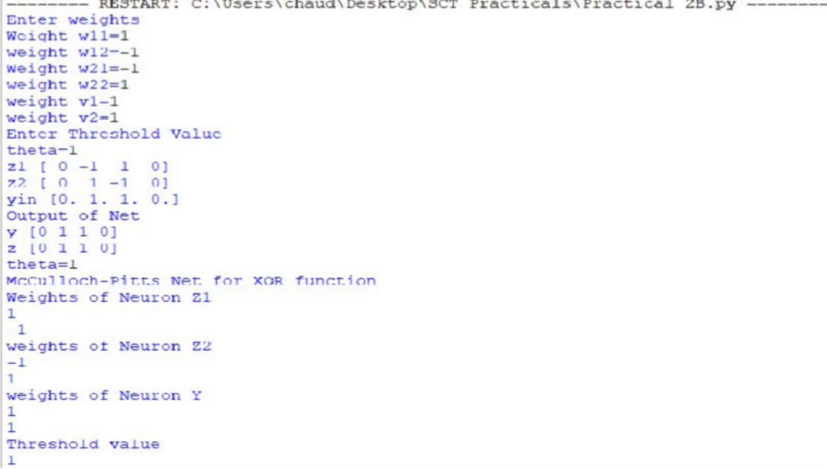

Practical 3a

Aim : Write a program to implement Hebb’s rule.
Code :
import numpy as np #first pattern
x1=np.array([1,1,1,-1,1,-1,1,1,1])
#second pattern x2=np.array([1,1,1,1,-1,1,1,1,1])
#initialize bais value b=0
#define target y=np.array([1,-1]) wtold=np.zeros((9,)) wtnew=np.zeros((9,)) wtnew=wtnew.astype(int) wtold=wtold.astype(int) bais=0
print("First input with target =1") for i in range(0,9): wtold[i]=wtold[i]+x1[i]*y[0] wtnew=wtold
b=b+y[0]
print("new wt =", wtnew) print("Bias value",b)
print("Second input with target =-1") for i in range(0,9): wtnew[i]=wtold[i]+x2[i]*y[1] b=b+y[1]
print("new wt =", wtnew) print("Bias value",b)

Output:
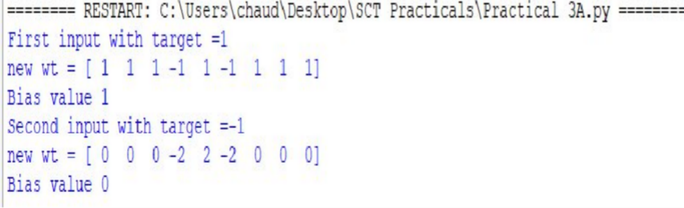

Practical 3b

Aim: Write a program to implement of delta rule.
Code :
#supervised learning import numpy as np import time
np.set_printoptions(precision=2) x=np.zeros((3,)) weights=np.zeros((3,)) desired=np.zeros((3,)) actual=np.zeros((3,))
for i in range(0,3): x[i]=float(input("Initial inputs:")) for i in range(0,3):
weights[i]=float(input("Initial weights:")) for i in range(0,3): desired[i]=float(input("Desired output:")) a=float(input("Enter learning rate:")) actual=x*weights
print("actual",actual) print("desired",desired) while True:
if np.array_equal(desired,actual): break #no change
else:
for i in range(0,3): weights[i]=weights[i]+a*(desired[i]-actual[i]) actual=x*weights
print("weights",weights) print("actual",actual) print("desired",desired) print("*"*30) print("Final output")
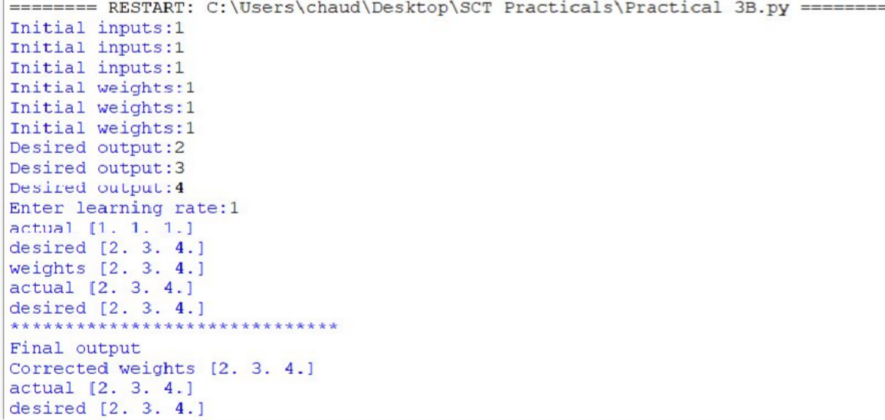
print("Corrected weights",weights) print("actual",actual) print("desired",desired)

OUTPUT:

Practical 4a

Aim: Write a program for Back Propagation Algorithm
Code :
import numpy as np import decimal import math
np.set_printoptions(precision=2) v1=np.array([0.6, 0.3])
v2=np.array([-0.1, 0.4])
w=np.array([-0.2,0.4,0.1]) b1=0.3
b2=0.5 x1=0 x2=1
alpha=0.25
print("calculate net input to z1 layer") zin1=round(b1+ x1*v1[0]+x2*v2[0],4) print("z1=",round(zin1,3)) print("calculate net input to z2 layer") zin2=round(b2+ x1*v1[1]+x2*v2[1],4) print("z2=",round(zin2,4))
print("Apply activation function to calculate output") z1=1/(1+math.exp(-zin1))
z1=round(z1,4) z2=1/(1+math.exp(-zin2)) z2=round(z2,4) print("z1=",z1)
print("z2=",z2)
print("calculate net input to output layer") yin=w[0]+z1*w[1]+z2*w[2] print("yin=",yin)
print("calculate net output") y=1/(1+math.exp(-yin)) print("y=",y)
fyin=y *(1- y) dk=(1-y)*fyin print("dk",dk)
dw1= alpha * dk * z1 dw2= alpha * dk * z2 dw0= alpha * dk
print("compute error portion in delta") din1=dk* w[1]
din2=dk* w[2] print("din1=",din1)

print("din2=",din2) print("error in delta") fzin1= z1 *(1-z1) print("fzin1",fzin1) d1=din1* fzin1 fzin2= z2 *(1-z2) print("fzin2",fzin2) d2=din2* fzin2 print("d1=",d1)
print("d2=",d2)
print("Changes in weights between input and hidden layer") dv11=alpha * d1 * x1
print("dv11=",dv11) dv21=alpha * d1 * x2 print("dv21=",dv21) dv01=alpha * d1 print("dv01=",dv01) dv12=alpha * d2 * x1 print("dv12=",dv12) dv22=alpha * d2 * x2 print("dv22=",dv22) dv02=alpha * d2 print("dv02=",dv02)
print("Final weights of network") v1[0]=v1[0]+dv11 v1[1]=v1[1]+dv12
print("v=",v1) v2[0]=v2[0]+dv21 v2[1]=v2[1]+dv22
print("v2",v2)
w[1]=w[1]+dw1
w[2]=w[2]+dw2 b1=b1+dv01 b2=b2+dv02 w[0]=w[0]+dw0
print("w=",w)
print("bias b1=",b1, " b2=",b2)

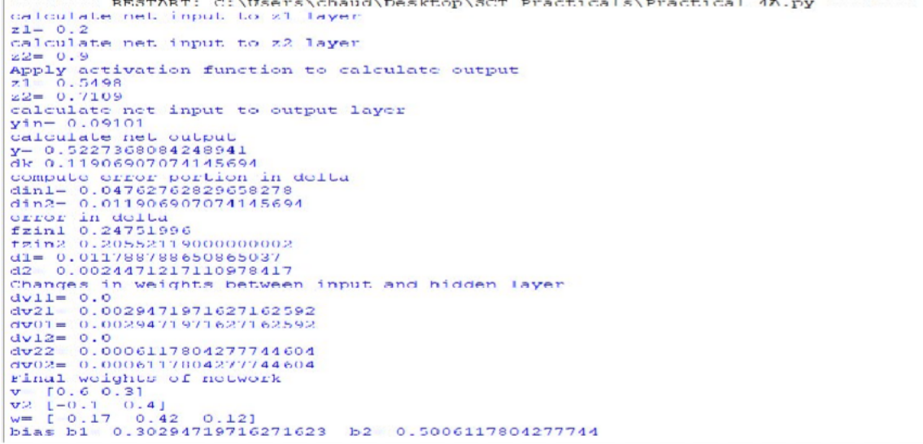
OUTPUT:

Practical 4b

Aim : Write a Program For Error Back Propagation Algorithm
Code :
import math a0=-1
t=-1
w10=float(input("Enter weight first network")) b10=float(input("Enter base first network:")) w20=float(input("Enter weight second network:")) b20=float(input("Enter base second network:")) c=float(input("Enter learning coefficient:")) n1=float(w10*c+b10)
a1=math.tanh(n1) n2=float(w20*a1+b20) a2=math.tanh(float(n2)) e=t-a2
s2=-2*(1-a2*a2)*e s1=(1-a1*a1)*w20*s2 w21=w20-(c*s2*a1) w11=w10-(c*s1*a0) b21=b20-(c*s2) b11=b10-(c*s1)
print("The updated weight of first n/w w11=",w11) print("The uploaded weight of second n/w w21= ",w21) print("The updated base of first n/w b10=",b10) print("The updated base of second n/w b20= ",b20)

Output:
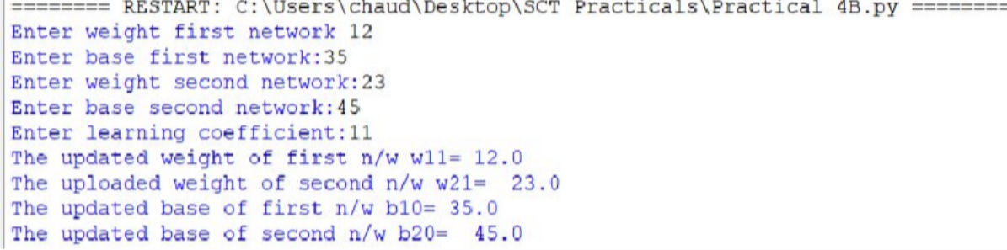

Practical 5

Aim: Write a program for Radial Basis function
Code:
from numpy import * from scipy import *
from scipy.linalg import norm, pinv from matplotlib import pyplot as plt class RBF:
def init(self, indim, numCenters, outdim): self.indim =indim
self.outdim =outdim self.numCenters =numCenters
self.centers =[random.uniform(-1, 1, indim) for i in range(numCenters)] self.beta =8
self.W =random.random((self.numCenters, self.outdim)) def _basisfunc(self, c, d):
assert len(d) ==self.indim
return exp(-self.beta *norm(c-d)**2) def _calcAct(self, X):
G =zeros((X.shape[0], self.numCenters), float) for ci, c in enumerate(self.centers):
for xi, x in enumerate(X): G[xi,ci] =self._basisfunc(c, x)
return G
def train(self, X, Y):
""" X: matrix of dimensions n x indim y: column vector of dimension n x 1 """
# choose random center vectors from training set
rnd_idx =random.permutation(X.shape[0])[:self.numCenters] self.centers =[X[i,:] for i in rnd_idx]
print("center", self.centers)
# calculate activations of RBFs G =self._calcAct(X)
print (G)
# calculate output weights (pseudoinverse) self.W =dot(pinv(G), Y)
def test(self, X): """ X: matrix"""
G =self._calcAct(X) Y =dot(G, self.W) return Y
if name=='main': #
1D Example n =100

x =mgrid[-1:1:complex(0,n)].reshape(n, 1) # set y and add random noise
y =sin(3*(x+0.5)**3-1)
# y += random.normal(0, 0.1, y.shape) # rbf regression

rbf =RBF(1, 10, 1)
rbf.train(x, y) z =rbf.test(x)
# plot original data plt.figure(figsize=(12, 8)) plt.plot(x, y, 'k-')
# plot learned model plt.plot(x, z, 'r-', linewidth=2) # plot rbfs
plt.plot(rbf.centers, zeros(rbf.numCenters), 'gs') for c in rbf.centers:
# RF prediction lines
cx =arange(c-0.7, c+0.7, 0.01)
cy =[rbf._basisfunc(array([cx_]), array([c])) for cx_ in cx] plt.plot(cx, cy, '-', color='gray', linewidth=0.2)
plt.xlim(-1.2, 1.2) plt.show()

Output:
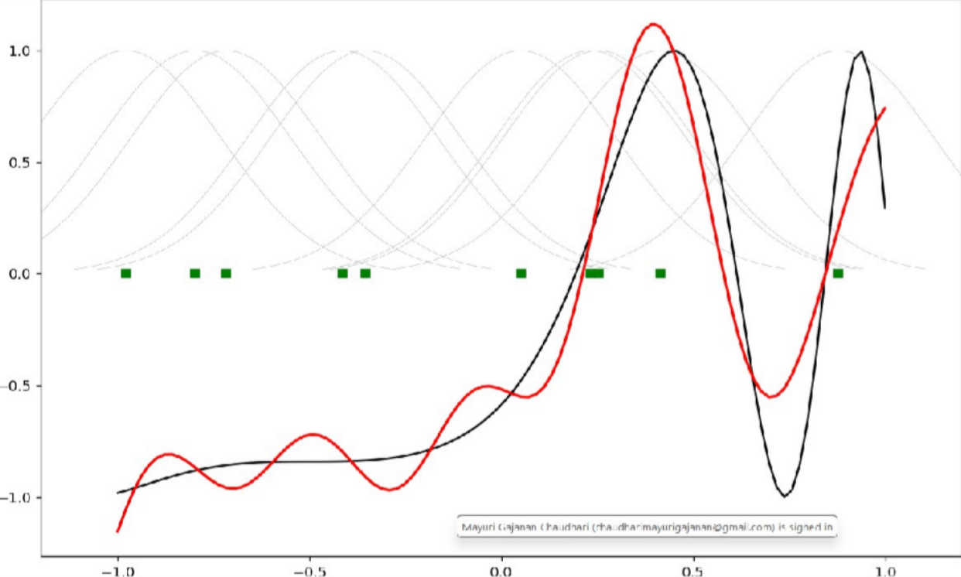

Practical 6

Aim: Write a program for Kohonen Self organizing map
Code :
from minisom import MiniSom import matplotlib.pyplot as plt data = [[ 0.80, 0.55, 0.22, 0.03],
[ 0.82, 0.50, 0.23, 0.03],
[ 0.80, 0.54, 0.22, 0.03],
[ 0.80, 0.53, 0.26, 0.03],
[ 0.79, 0.56, 0.22, 0.03],
[ 0.75, 0.60, 0.25, 0.03],
[ 0.77, 0.59, 0.22, 0.03]]
som = MiniSom(6, 6, 4, sigma=0.3, learning_rate=0.5) # initialization of 6x6 SOM som.train_random(data, 100) # trains the SOM with 100 iterations plt.imshow(som.distance_map())
plt.show()

Output:
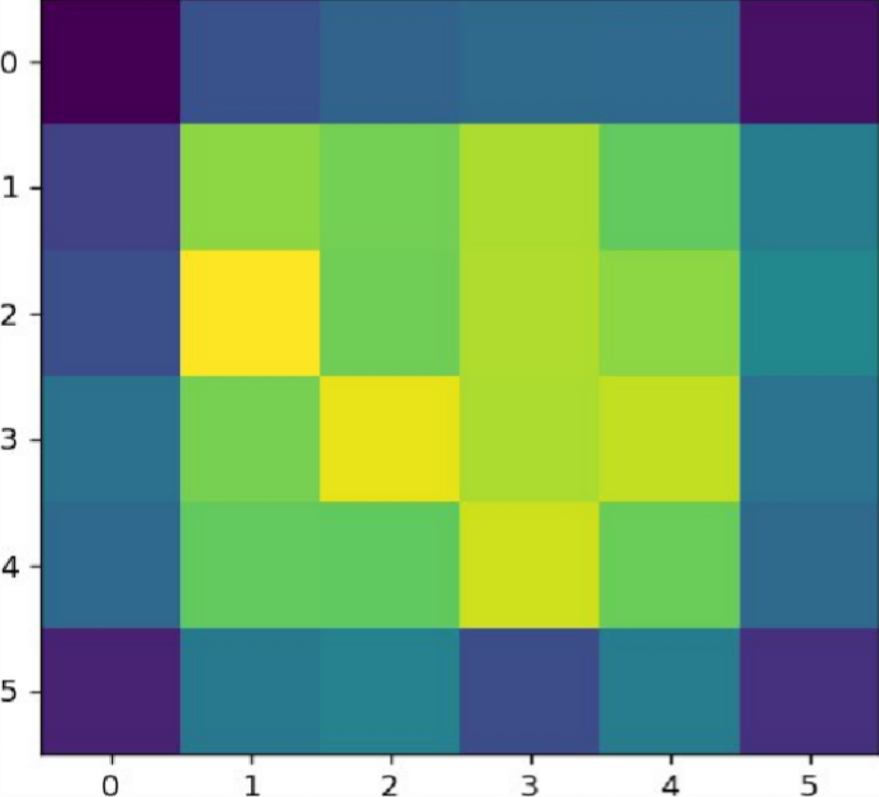

Practical 7

Aim: Write a program for Linear separation.
Code :
import numpy as np
import matplotlib.pyplot as plt
def create_distance_function(a, b, c):
""" 0 = ax + by + c """ def distance(x, y):
""" returns tuple (d, pos) d is the distance
If pos == -1 point is below the line, 0 on the line and +1 if above the line """
nom = a * x + b * y + c if nom == 0:
pos = 0
elif (nom<0 and b<0) or (nom>0 and b>0): pos = -1
else:
pos = 1
return (np.absolute(nom) / np.sqrt( a ** 2 + b ** 2), pos) return distance
points = [ (3.5, 1.8), (1.1, 3.9) ]
fig, ax = plt.subplots() ax.set_xlabel("sweetness") ax.set_ylabel("sourness") ax.set_xlim([-1, 6])
ax.set_ylim([-1, 8])
X = np.arange(-0.5, 5, 0.1)
colors = ["r", ""] # for the samples size = 10
for (index, (x, y)) in enumerate(points):
if index== 0:
ax.plot(x, y, "o", color="darkorange", markersize=size) else:
ax.plot(x, y, "oy", markersize=size) step = 0.05
for x in np.arange(0, 1+step, step):
slope = np.tan(np.arccos(x))
dist4line1 = create_distance_function(slope, -1, 0) #print("x: ", x, "slope: ", slope)
Y = slope * X results = []
for point in points:

results.append(dist4line1(*point)) #print(slope, results)
if (results[0][1] != results[1][1]): ax.plot(X, Y, "g-")
else:
ax.plot(X, Y, "r-") plt.show()

Output:

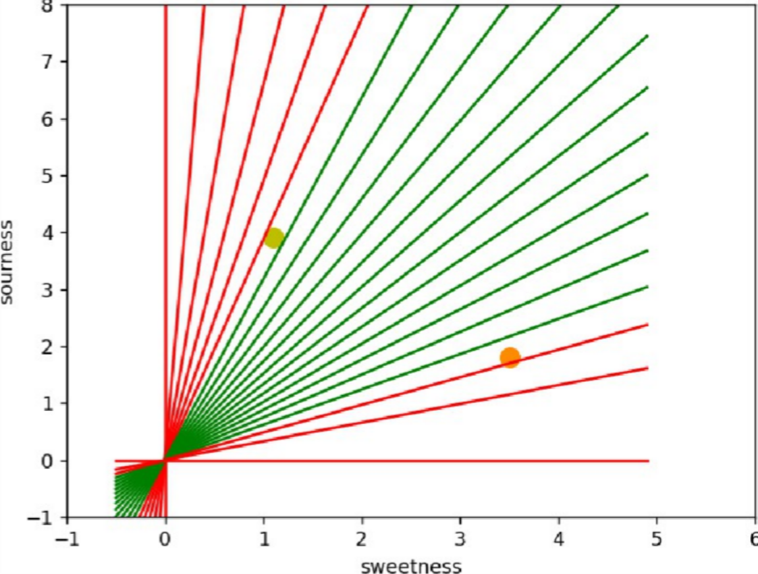

Practical 8A

Aim: Membership and Identity Operators | in, not in,
Code :
# Python program to illustrate
# Finding common member in list # without using 'in' operator
# Define a function() that takes two lists def overlapping(list1,list2):
c=0 d=0
for i in list1:
c+=1
for i in list2:
d+=1
for i in range(0,c): for j in range(0,d): if(list1[i]==list2[j]): return 1
return 0 list1=[1,2,3,4,6]
list2=[6,7,8,9]
if(overlapping(list1,list2)): print("overlapping")
else:
print("not overlapping")
Output: overlapping

Practical 8b

Aim: Membership and Identity Operators is, is not
Code :
# Python program to illustrate the use # of 'is' identity operator
'''x = 5
if (type(x) is int):
print ("true") else:
print ("false")'''
# Python program to illustrate the # use of 'is not' identity operator x = 1
if (type(x) is not int): print ("true")
else:
print ("false")

Output: false

Practical 9a

Aim: Find the ratios using fuzzy logic
Code :
# Python code showing all the ratios together,
# make sure you have installed fuzzywuzzy module from fuzzywuzzy import fuzz
from fuzzywuzzy import process s1 = "I love fuzzysforfuzzys"
s2 = "I am loving fuzzysforfuzzys"
print ("FuzzyWuzzy Ratio:", fuzz.ratio(s1, s2))
print ("FuzzyWuzzyPartialRatio: ", fuzz.partial_ratio(s1, s2))
print ("FuzzyWuzzyTokenSortRatio: ", fuzz.token_sort_ratio(s1, s2)) print ("FuzzyWuzzyTokenSetRatio: ", fuzz.token_set_ratio(s1, s2)) print ("FuzzyWuzzyWRatio: ", fuzz.WRatio(s1, s2),'\n\n')
# for process library, query = 'fuzzys for fuzzys'
choices = ['fuzzy for fuzzy', 'fuzzy fuzzy', 'g. for fuzzys'] print ("List of ratios: ")
print (process.extract(query, choices), '\n')
print ("Best among the above list: ",process.extractOne(query, choices))

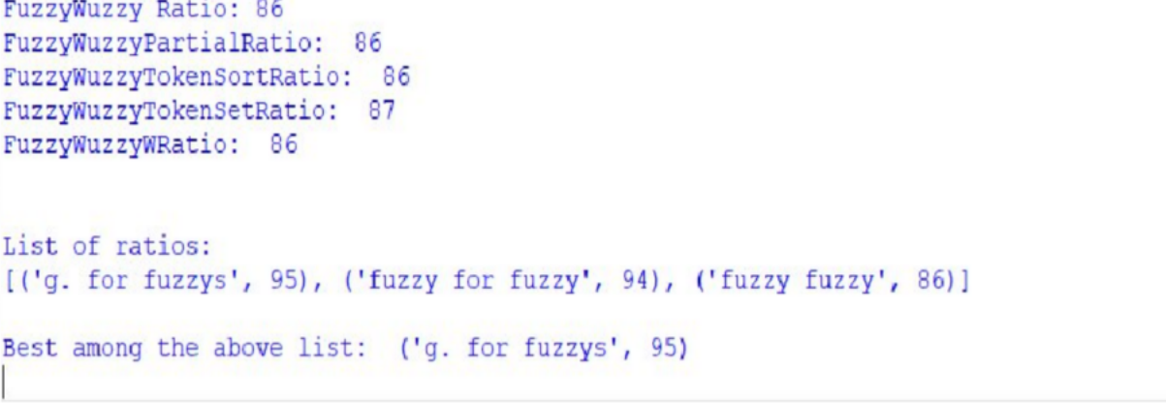
Output:

Practical 9b

Aim: Solve Tipping Problem using fuzzy logic
Code :
import numpy as np import skfuzzy as fuzz
from skfuzzy import control as ctrl
quality = ctrl.Antecedent(np.arange(0, 11, 1), 'quality')
service = ctrl.Antecedent(np.arange(0, 11, 1), 'service')
tip = ctrl.Consequent(np.arange(0, 26, 1), 'tip') quality.automf(3)
service.automf(3)
tip['low'] = fuzz.trimf(tip.universe, [0, 0, 13])
tip['medium'] = fuzz.trimf(tip.universe, [0, 13, 25])
tip['high'] = fuzz.trimf(tip.universe, [13, 25, 25]) quality['average'].view()
service.view() tip.view()
rule1 = ctrl.Rule(quality['poor'] | service['poor'], tip['low']) rule2 = ctrl.Rule(service['average'], tip['medium'])
rule3 = ctrl.Rule(service['good'] | quality['good'], tip['high']) rule1.view()
tipping_ctrl = ctrl.ControlSystem([rule1, rule2, rule3]) tipping = ctrl.ControlSystemSimulation(tipping_ctrl)
# Pass inputs to the ControlSystem using Antecedent labels with Pythonic API tipping.input['quality'] = 6.5
tipping.input['service'] = 9.8 # Crunch the numbers tipping.compute() print(tipping.output['tip']) tip.view(sim=tipping)

Output:

